

This document will list steps needed to setup your Discovered.tv account and publish your video content.
- Using Chrome browser on your Windows PC/Mac computer, go to https://discovered.tv. Optimizations for mobile devices and mobile app will be available soon.
- Scroll down till you see
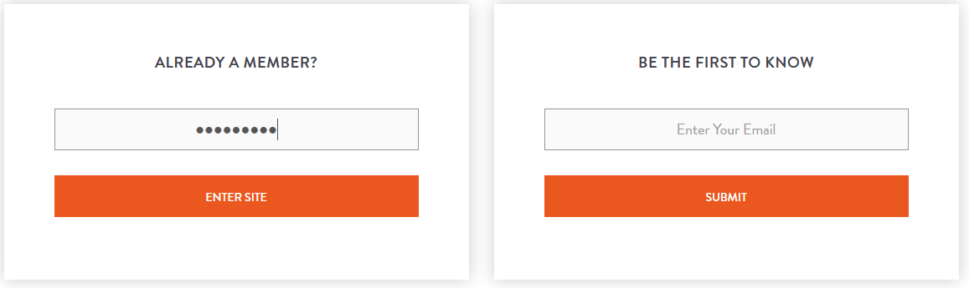
In the “ALREADY A MEMBER” section, enter SantaCruz as password and click on ENTER SITE button. This will take you to the homepage of discovered.tv
Once we are past Beta testing, this step will not be required.
- As a new user, click on SIGN UP tab.
- You can create an account by using your Google/Facebook ID as well.
- To finish creating your account, you need to confirm your email.
- Follow the steps on the screen to set up your account, including validation step thru your contact email.
- You need to be ready with a UNIQUE DISPLAY NAME that will be associated with your Discovered account. Once you choose a UNIQUE DISPLAY NAME, it cannot be changed on discovered.tv
- Tag yourselves as an ICON or emerging creator in your category. Icon= Past or current content in Indy or major distribution channel. Emerging = not currently distributed
If you're having a problem creating a Discovered account, send an email with screenshot of the error message to feedback@discovered.tv
- Once you are past the SIGNUP steps, use the account you created to LOGIN to Discovered.

HOW TO PUBLISH VIDEOS, AND MANAGE YOUR PROFILE PAGE

YOUR PROFILE PAGE
Your Profile page is what you see when you log into Discovered.
This is the one place where you can manage all your Discovered related activities including but not limited to social posts, content, fans, endorsements, news feed, links to fellow content creators home pages and other connections you've made.
MY CHANNEL page is similar to your YouTube page. SOCIAL PROFILE is similar to your Instagram or Facebook page.
HOW TO PUBLISH A VIDEO
You can upload video’s using two routes on Discovered.tv, after you login to your account.
- UPLOAD OFFICIAL VIDEO
- SOCIAL PROFILE page

You can upload multiple videos, but you can have only one cover video at a time. Your cover video is the one that runs on your main home page once you login to discovered.
a.i) For uploading thru UPLOAD OFFICIAL VIDEO, click on the tab, as shown
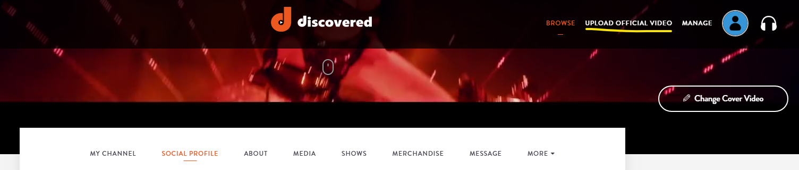
a.ii) Ideally your video content, would need to be in HD quality mp4 format to be upload-able to Discovered.
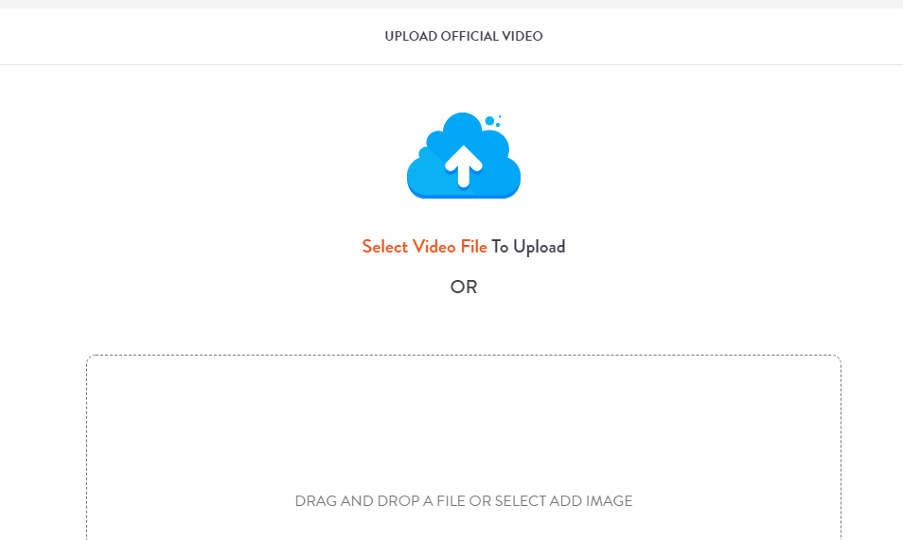
a.iii) You can either click to browse thru your computer folder OR drag and drop the video file (one at a time).
a.iv) You will see the UPLOAD progress bar moving to indicate the status. Depending on your internet upload speed, typically it takes about 3 to 5 min for a 4 min video clips/ 80 MB files.
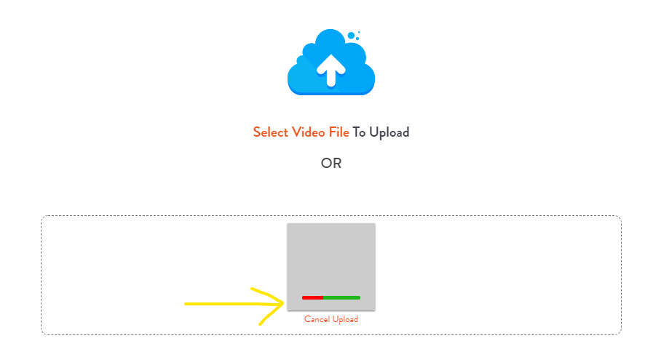
a.v) Once the video upload is done, you will be provided with option of choosing from 3 thumbnail images, and optionally you can upload a 4th thumbnail image of your choice.
To better categorize and curate the video content, please fill-in the details as shown in picture below like mode (music, movie or television), genre, category, language, age restrictions etc. Be as accurate as possible so that we can help your video to be Discovered!
Please place as many Tags and descriptive words as you can to help your content be found and monetized in the Discovered system.
To monetize your video content, choose PUBLIC option under Select Privacy pick list. Unlike many Social Platforms, in Discovered your content can be monetized in both your Social feed and Channel. Please upload your content to both.
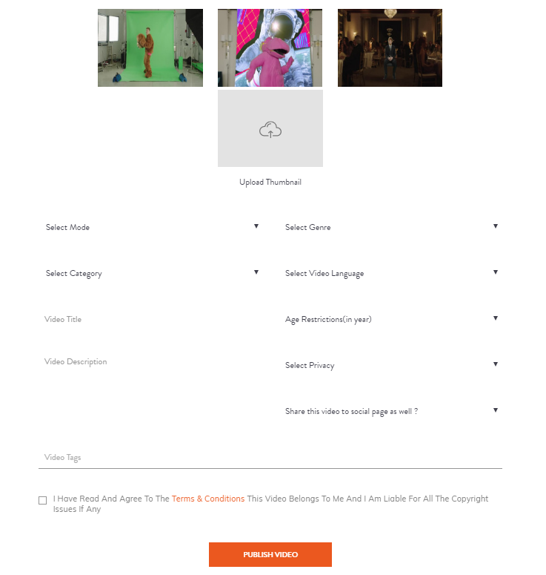
After completing the profile information for your video, and accept the terms and conditions, hit the PUBLISH VIDEO button.
Upon successful upload, you should be seeing below image as confirmation.


b) You can also upload video(s), thru your SOCIAL PROFILE page.
Your SOCIAL PROFILE, is one place where you can manage all your Discovered related activities.
Currently the MY CHANNEL, SOCIAL PROFILE, ABOUT tabs are being enabled in Beta version.

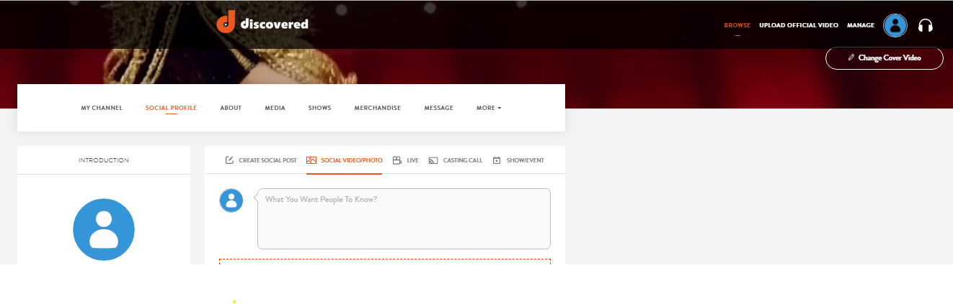
In the SOCIAL VIDEO/PHOTO tab, you can upload mp4 file for video content and photos can be jpeg format to publish it on discovered.



